# Module 6 Assignment 2 GitHub link:

# <https://github.com/xeno1211/M6A2>

# Screenshots:

# Register

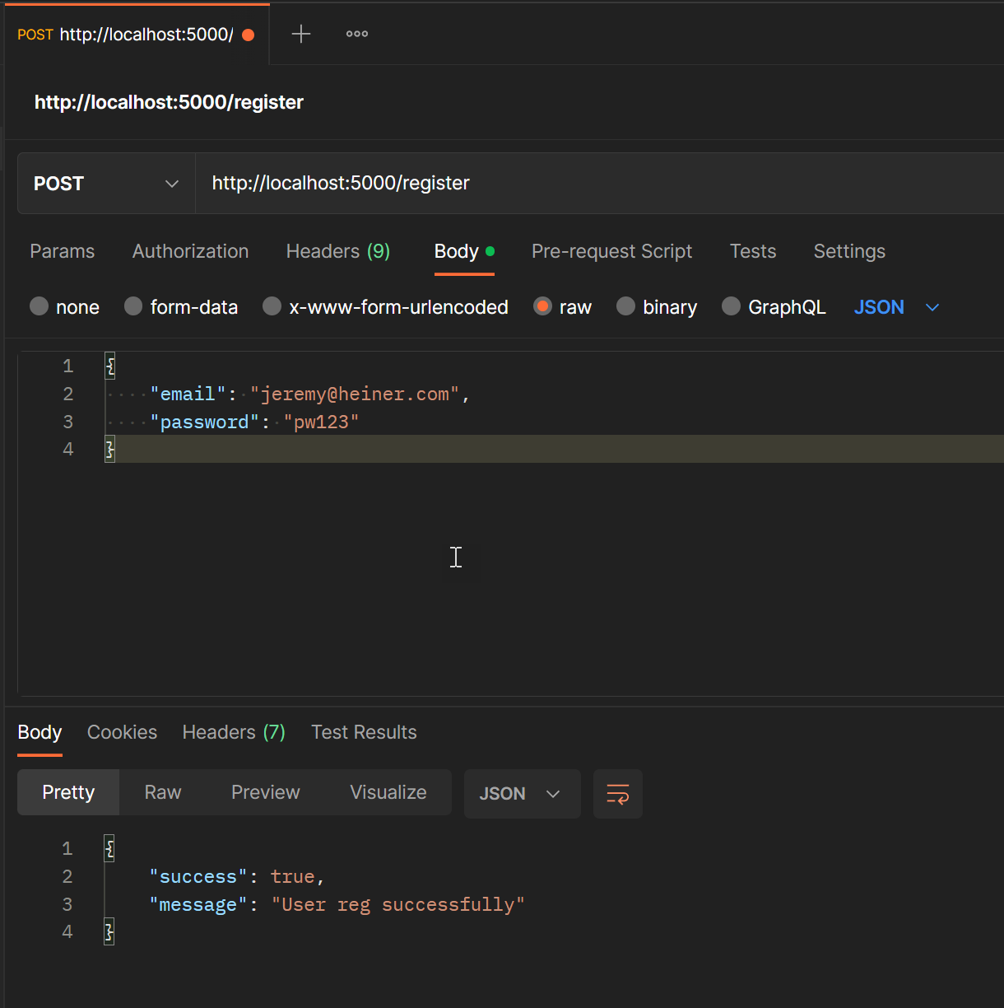

# Login

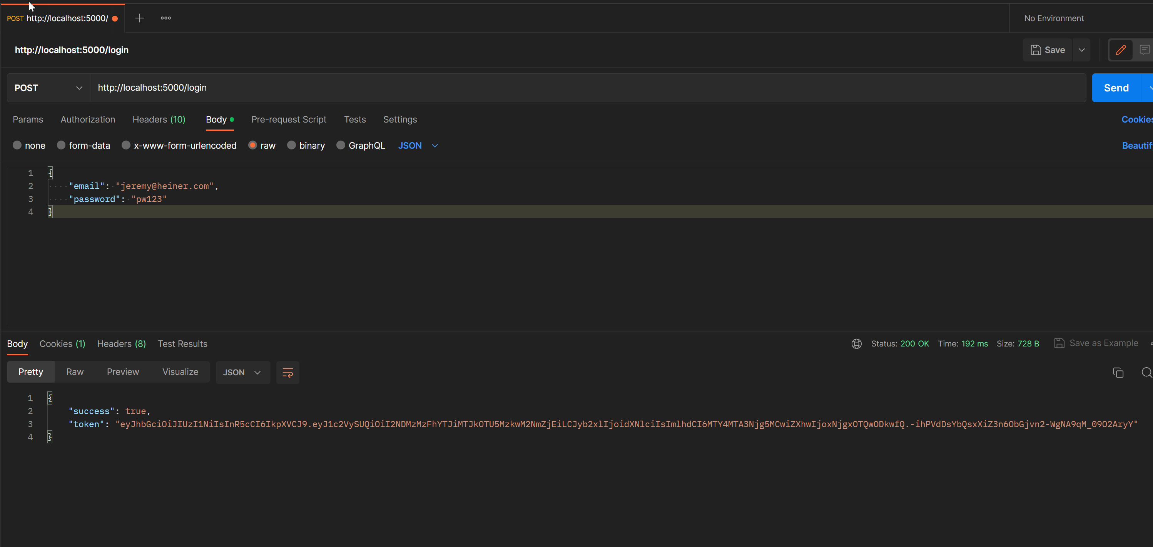

# Protected

Admin User



Regular User

